Tip #1

Be quick and reuse with Quick Parts

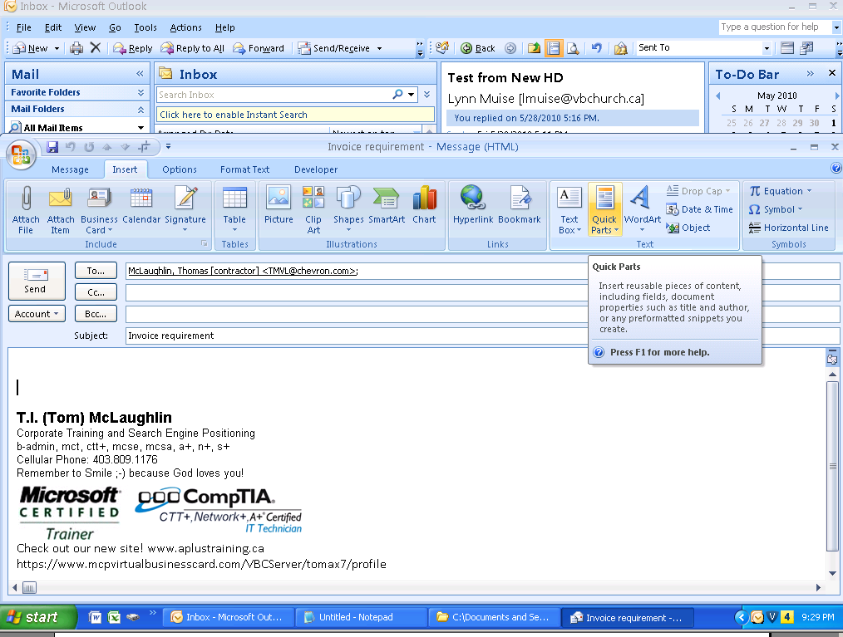
Quick Parts is a feature that’s found in Outlook 2007 and MS Word. If you use text, links or images repeatedly in your emails, then Quick Parts can save you a lot of typing!

To Create the Quick Part
- Open a new Email, and create/type the text and image you require.
- Highlight what you have created
- Under Insert tab, select Quick Parts and choose ‘Save Selection to Quick Part Gallery”
Give it a name that will help you remember what it is in the future.

Using the Quick Part
- Open a new Email,
- Go to Insert tab, then click on Quick Parts button,
- Select your Quick Part by clicking inside the box the Quick Part you have created.

TIP #2.

Avoid the earlier point by marking special emails by color

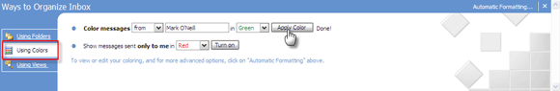

Important emails from important senders should stand out from the chaos that’s usually our Inbox. The easiest way is to of course put them in a separate category. The second easiest visually striking way is to mark them by color.

Select a message from the important contact. From the menu, click on Tools – Organize. This opens a section on top.

- Choose the second option – Using Colors.
- Select your preferred color and click on Apply Color. You can also pick a color for Show messages sent only to me as a way to mark out messages that’s only for you and not a group mail. Further, you can click on Automatic Formatting to apply more rules and to use a different font.
- Click the close button [X] after you are done.

Tip #3.

Display Week Numbers

When scheduling appointments in Microsoft Outlook 2007, it might prove useful to display each week's number (perhaps you need to schedule an appointment every 3 weeks or whatever). Making this change to the calendar view in the Month view, as well as the Date Navigator in the To-Do Bar, is easy.

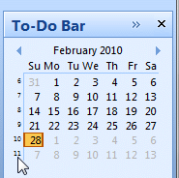

NOTES:
1. Select "Tools" - "Options".
2. The "Options" multi-tabbed dialog box appears. Click the "Preferences" tab.
3. Underneath "Calendar", click the "Calendar Options" button.
4. Underneath "Calendar options", check "Show week numbers in the Month View and Date Navigator".
5. Click "OK" on the dialog boxes to close them.

TIP #4

Show an Additional Time Zone in the Calendar

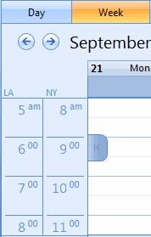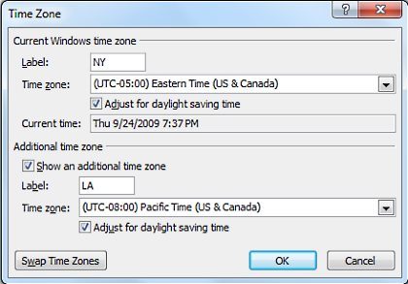
Display two time zones in Outlook 2007's Calendar for different areas.

NOTES:
1. While in Calendar view, right click on the Time column.
2. Select “Change Time Zone" item (half way down)
3. The "Time Zone" dialog box appears.
4. Check "Show an additional time zone". (Remember to give each time zone a label)
5. Next to "Time zone", click the pull-down and select the alternate time zone to display.
6. Check or uncheck "Adjust for daylight saving time" next to each time zone as needed.
7. When done, click "OK" on the dialog boxes to close them.

TIP #5

Attach and send in one smooth flow

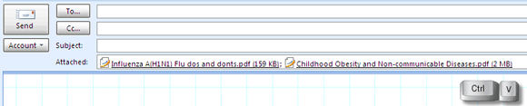

1. Open a new email.
2. Copy one or more of the documents you wish to send from Windows Explorer/ eDocs.
3. Paste Click in the Body part of your email and it will automatically crate an Attachment.

Tip #6

Add country-specific and religious holidays to your calendar.
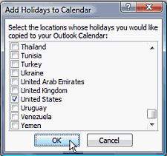

Notes:
1. Select "Tools" - "Options".
2. The "Options" multi-tabbed dialog box appears. Click the "Preferences" tab.
3. Underneath "Calendar", click the "Calendar Options" button.
4. The "Calendar Options" dialog box appears.
5. Click the "Add Holidays" button.
6. An "Add Holidays to Calendar" dialog box appears. Scroll through the list of holidays and check what you wish to add.
7. Click "OK" on the dialog boxes to close them.

TIP #7

Work across time zones

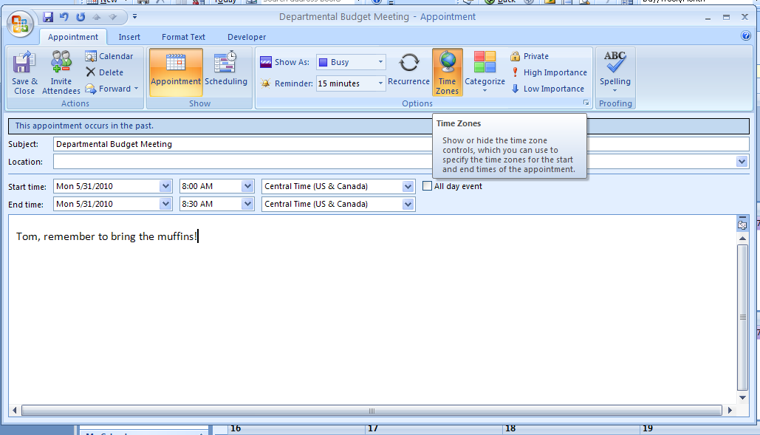

- Create a new appointment, click the Time Zone icon on the toolbar,
- From the time zone list, choose the other person's time zone.

For example, if your meeting is at 10am Houston time, select 10am for the time and then choose GMT + 5 Canberra, Melbourne, Sydney from the list.

TIP #8

Start in a Different Folder

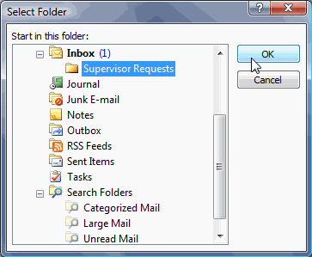
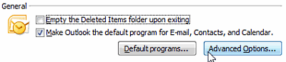
NOTES:
- Select "Tools" then "Options".
- In the "Options" box click the "Other" tab.
- Underneath "General", click the "Advanced Options" button.
- The "Advanced Options" dialog box appears. Next to "Startup in this folder", click the "Browse" button.
- A list of folders appears. Click your desired startup folder,
- Click "OK" on the dialog boxes to close them.

TIP #9

Change Calendar Default Reminder Time

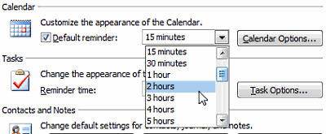

NOTES:
1. Select "Tools" then "Options".
2. In the "Options" box click the "Preferences" tab.
3. Underneath "Calendar" group please make sure "Default Reminder" is checked.
4. Next to the checkbox, click on the pull-down and change the reminder time as desired.
(Or, you can manually enter the amount of reminder time.)
5. Click "OK" to close the dialog box.

Tip #10

Change Calendar Font in Navigation Pane
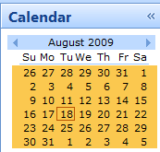 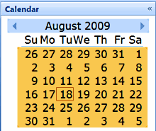
Before and After
NOTES:
1. Select "Tools" - "Options".
2. The "Options" multi-tabbed dialog box appears. Click the "Other" tab.
3. Underneath "General", click the "Advanced Options" button.
4. The "Advanced Options" dialog box appears. Underneath "Appearance options", next to "Date Navigator" click the "Font" button.
5. A standard "Font" dialog box will appear where you can change the font name, size, and style.
Note that fonts larger than 8 pt. may either not appear correctly in Outlook, or you may have to increase the width of the Navigation Pane.
6. After making your selections, click "OK" on the three dialog boxes to close them.

Extra TIPs

Give your old emails a new name
We all have ‘threads’ of email conversations in our inbox.

Mails which started out with a ‘Hi’ in the subject field and after a few exchanges started discussing something important like a new salary breakdown. The content has shifted but the starter subject line does nothing for us.

Changing the subject line to reflect the content is a best practice especially when you have hundreds of mails archived in Outlook. Changing the subject line is fortunately as easy as the first time.

- Open the email with the subject line in need of change in a new window.
- Place the cursor on the subject line and type in your new appropriate subject.
- Confirm and close.

